CRCD Set Up Instructions

Many of the courses are coming in with different CRCD set up (mostly because the default setup is being used when you first opened it). Below is what NADAC would like you to do to set up the CRCD format so everyone is using the same aframe size, weave pole lengths, jump width, dog path properties, etc. Please make sure your CRCD is set up with the below format before you start course designing. Once you set up, it should all default to the new set up each time you start to design a course.
If your courses come to NADAC and they are not in the proper set up/format, then they will be returned to you.
Setting the course grid. Open a NEW blank map grid. Right click on the course and select at the very bottom of the menu, “Obstacle coordinates and grid”. On the next menu, it should be set up like this below: Then hit OK.

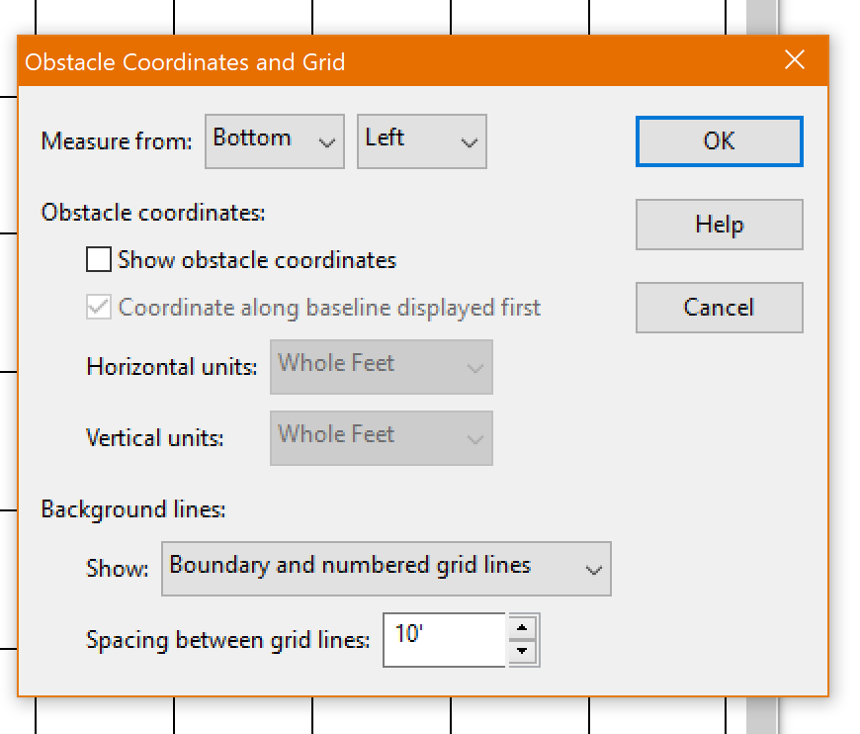

To set your course size, right click on the map and in the menu, select the “Course Size”. The new menu will allow you to change your width and your height. Hit OK. Acceptable course sizes: 80x100, 80x120, 90x90, 100x100. 70x120 is acceptable for a few grandfathered club rings. If a club’s ring is 90x100, please design a 90x90 set, so we can use your courses in other areas and not just that one trial.

To set up the correct dog path distances, right click on the blank map and select “Jump Height and Length”. Change the jump height to 12”. Then hit OK

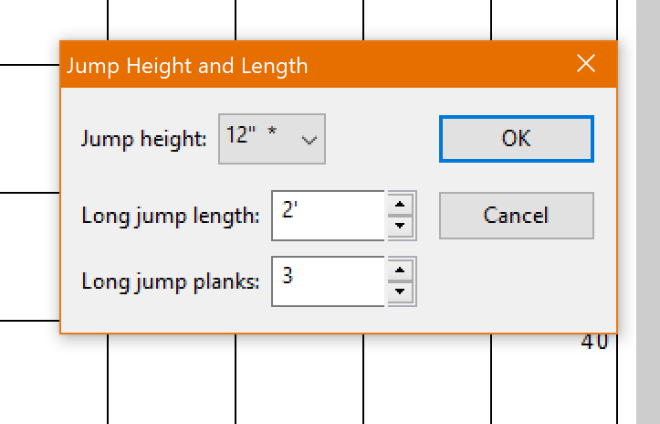
Make sure the A-frame is set to 9’. Select the aframe icon, then select the Properties” button below the icons. Change to 9’ planks if necessary and hit OK.
Make sure the Weave Poles are set to 24” spacing between poles. Select the weave pole icon and select the properties button, and make sure the Weave pole spacing is set to 24”, then hit OK.
Set the Jump size properties to 4’6”.

. 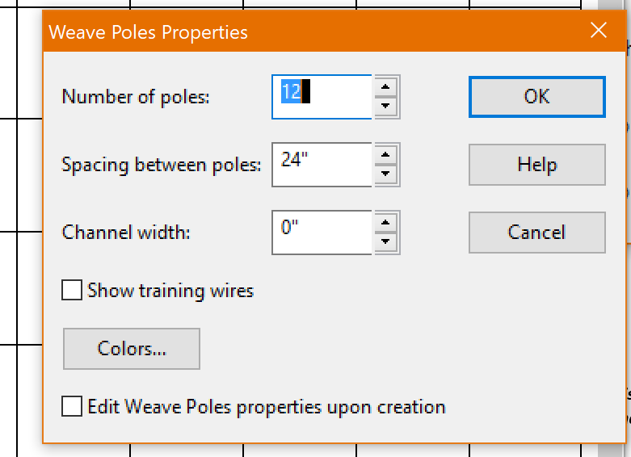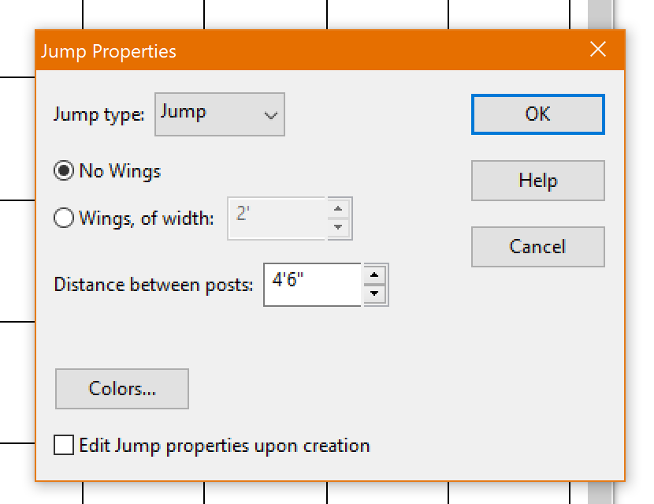

- When you type in the course name and level on your map, please use this format.

Course Name Level Course Type
Sleepy Elite Regular 1

All Course names should be in the top left of the course. You can do this easily by setting the properties at the same time you are typing in your text. If you set the “Resizing course border to fit text” to TOP, the text will automatically create a text box above your map. It will not default to Top, so you will need to change it for each text box you type in.

Uncheck the “Show box around text” if yours is checked.

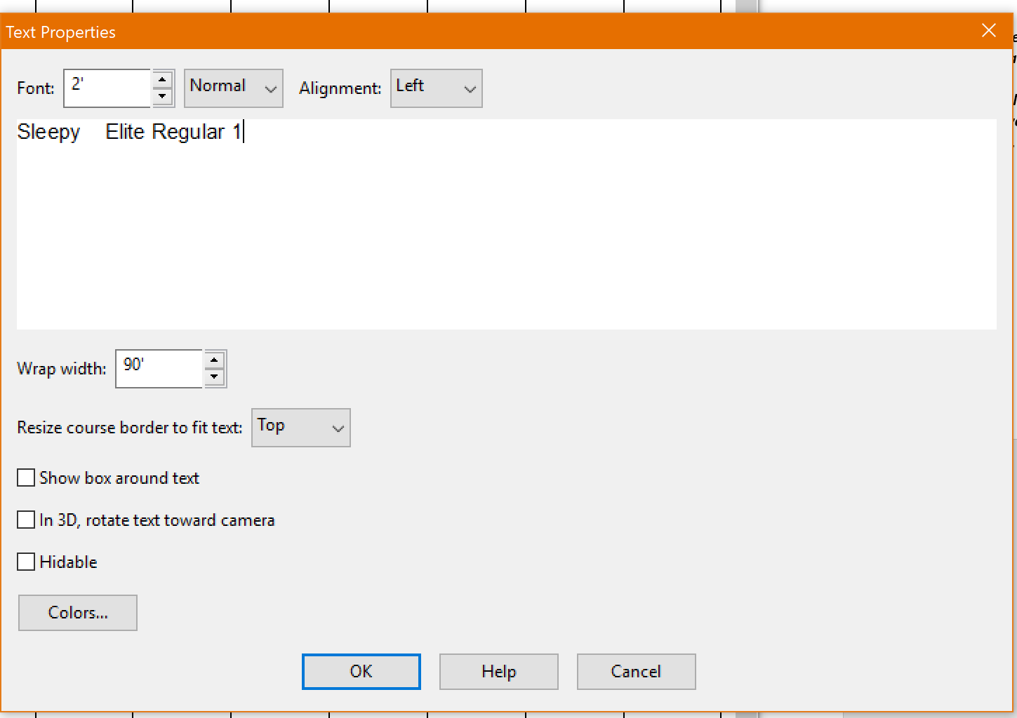

When you save your courses in a file, please name your file folder like this: 1010-Pepsi-(Your name), 0812-Pepsi-Marj, 0810-Pepsi-Marj, 0712-Pepsi-Marj, 0909-Pepsi-Marj. This format allows us to sort the courses by size at the office.
This icon allows you to make multiple copies of your obstacle. Very nice for creating jumpers. Click on your jump icon and then click the duplicate icon. Both will highlight and you can click the map multiple times and a jump will appear for each click of the map. You can use this for numbering also.

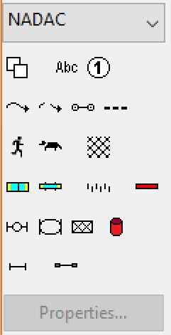
The path distances should be checked when you are done with your course design and every thing is numbered. Click the icon and then click the map. The distances between obstacles will appear. 21’ is the optimal for all distances between obstacles.

To check the dog path distances, click on the path icon and then click anywhere on the course map. If your course is numbered, your distances between obstacles will appear for the entire course. If it doesn’t, you may need to adjust the path properties by clicking the path icon, and select ‘Properties” and then adjust the menu box to look like this:
: 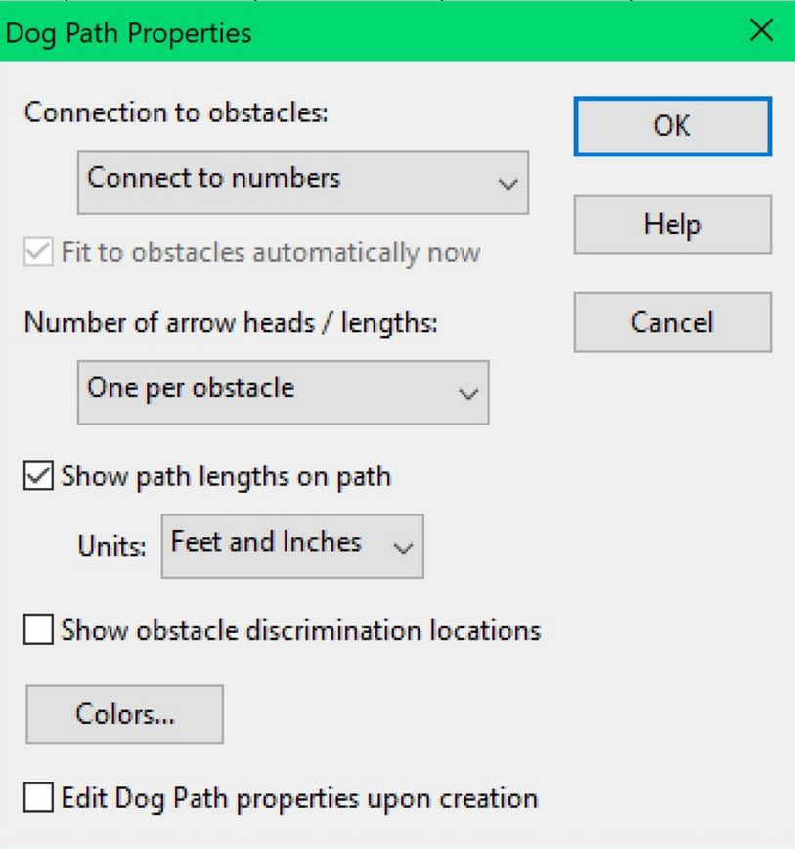
Please adjust the “Show Path lengths on path” to be Feet and Inches.

If you want to make one short course path, without connecting to numbers, you can change the path properties, “connection to numbers” to read “Connect to obstacles manually”.

FYI…The dog path will not connect to numbers if there is a barrel on the course. We suggest you remove the barrel and replace with a hoop, then do the dog path distances. Then once you have the appropriate distances set, reinstall your barrel.

The tunnel properties are a bit different in CRCD 3 then the newer CRCD 4. In CRCD 4, you can no longer rotate the tunnel unless you have it set as “FIXED angle” in the properties. But….you cannot adjust the shape when it is set to fixed, so I prefer to have my tunnel properties set like this:
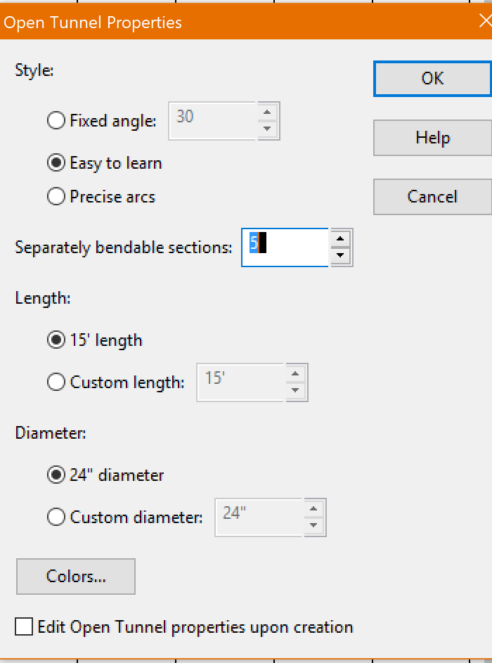

If you set the bendable sections to 5, you can put the tunnel in just about any shape you choose. It will default to only 3 handles, and it is harder to make the shape you desire with only 3 handles. But once you set to 5 handles it will always default to that.

Here is a usage tip for the Precise Arc option in the tunnel properties: You need to practice this one and see if you like it. I find it a bit harder to use then the Easy to Learn option.

. 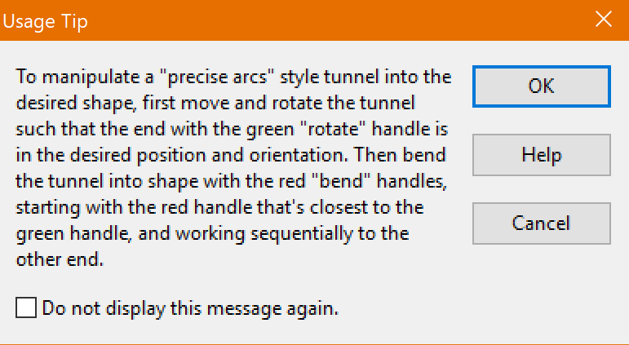

When placing the number on a bi-directional barrel, please place it in front of the barrel. This will replicate the position of the cone when numbering on the ground. Also, please make a note at the top of the map that it is a bi-directional barrel. Or if it is a 360 turn around the barrel.
.

