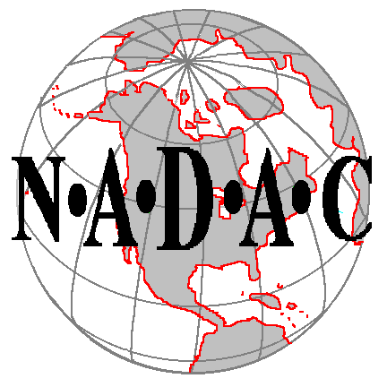

NORTH AMERICAN DOG AGILITY COUNCIL

Sanctioned Group Application

Group NAME:

CONTACT PERSON:

NADAC Membership Number: Expiration Date: (required)

Street Address: Phone:

City: State: Postal Code:

E-Mail:

The designated Contact Person is required to join the NADAC Forum at www.NADAC.com/Forum maintain a valid e-mail address.
You will also be listed as the Contact on the list of NADAC Sanctioned Clubs.

OFFICERS:

Name of President: Phone:

Street Address:

E-Mail:

Name of Secretary: Phone:

Street Address:

E-Mail:

Name of Treasurer: Phone:

Street Address:

E-Mail:

Name of
INSURANCE COMPANY: Policy #

Street Address: Policy
Expiration Date:

City: State: Postal Code: Phone Number:

PLEASE ATTACH A COPY OF PROOF OF INSURANCE

List of Available Equipment in Good Repair and that meets NADAC’s Specifications:

#_____ Dog Walk #_____ Wingless Jumps Weave Poles:
#_____ A-Frame #_____ Winged Jumps #_____ sets of 6
#_____ Open Tunnels #_____ Hoops #_____ sets of 12

PLEASE NOTE: There is a $100.00 (US Funds) Application Fee due with the submission of this form.

By signing this application, I/we agree that one of the purposes of this Group is to support the sport of dog agility for all dogs, including mixed breeds, and that the Group supports the humane treatment of animals.

President: Date:

Group
Contact Person: Date:

Please email completed application and insurance to Support@nadac.com

North American Dog Agility Council
24605 Dodds Road
Bend, OR 97701
e-mail: Support@nadac.com

