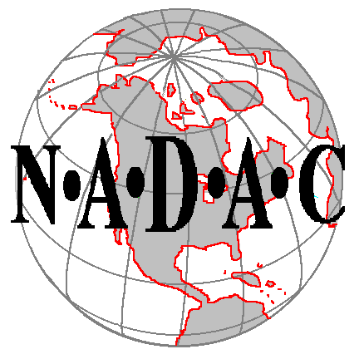

NORTH AMERICAN DOG AGILITY COUNCIL

Sanctioned Group Renewal

Group NAME:

CONTACT PERSON:

NADAC Membership Number: Expiration Date: (required)

Street Address: Home Phone:

City: State: Postal Code:

E-Mail:

The designated Contact Person is required to join the NADAC Forum at www.NADACForum.com Trial Secretaries section, and maintain a valid e-mail address. You will also be listed as the Contact on the list of NADAC Sanctioned Clubs.

OFFICERS:

Name of President: Phone:

Street Address:

E-Mail:

Name of Secretary: Phone:

Street Address:

E-Mail:

Name of Treasurer: Phone:

Street Address:

E-Mail:

Name of
INSURANCE COMPANY: Policy #

Street Address: Policy
Expiration Date:

City: State: Postal Code: Phone Number:

The annual Group Renewal fee is $25.00 if paid by Dec. 31st

Group renewal fee if paid by December 31st ……………. $25.00 $_______________________
Group renewal fee if paid between Jan. 1st & Jan. 15th..… .$50.00 $_______________________
Group renewal fee if paid between Jan. 16th & Jan. 31st… $75.00 $_______________________

NOTE: Clubs are required to submit a Sanctioned Group Application, supporting documents, and a new club fee of $100.00 if they have not renewed by Jan. 31st.

By signing this application, I/we agree that one of the purposes of this Group is to support the sport of dog agility for all dogs, including mixed breeds, and that the Group supports the humane treatment of animals.

President: Date:

Group
Contact Person: Date:

Return completed renewal form and renewal fee to:

North American Dog Agility Council
24605 Dodds Road, Bend, OR 97701
e-mail: NadacOffice2@aol.com

