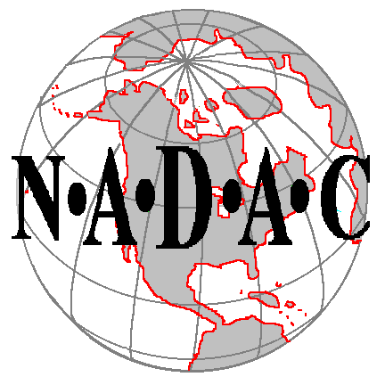

NORTH AMERICAN DOG AGILITY COUNCIL

Trial Application Form

Applications are due 16 weeks prior to the date of the trial

Please Type or Print Clearly Incomplete or Illegible forms will be returned

The class sanctioning fee is due with submission of application

Group / Club Name:
Week Number:  Required |  | (Please refer to the List of Past Trials in the General Secretaries section at http://NADACforum.com)
Date(s) Requested: |  | (It is assumed that the host group will honor all trials within 200 miles of their trial.)
Location (City / State):
Address of Trial Site:

Size of Actual Ring(s): (Required: drawing of ring area, crating, restrooms, spectator area, parking)

Ring #1 width = |  | length =
Ring #2 width = |  | length =

Trial Area Surface: |  | (Specify grass, dirt, sand,, bark, matting, etc.)
Trial Chair Name: |  | E-Mail Address:
Street Address: |  | Phone: | ( )
City, State ZIP
Trial Secretary Name: |  | E-Mail Address:
Street Address: |  | Phone: | ( )
City, State ZIP
The following to be listed on the NADAC web page Calendar of Events:
Show Contact:
E-mail:
Web Site:

Acceptable Formats:

A maximum 6 classes per day may be offered. Of those 6 classes, 4 classes may include jumps.
An additional 2 runs of either Hoopers or Barrelers may be offered on any weekend day.
Clubs may offer less than 6 runs per day.
Classes & Maximum # per 2-day weekend:
Jumping Class Trial: (maximum of 6 classes ea. day/4 with jumps) Regular Agility (4)
Regular Agility and Jumpers must be offered. Jumpers (2)
Chances (2)
------------------------------------------------------------------------------------------------------------------------------------------------------------------
Classes & Maximum # per 2-day weekend:
Non Jumping Class Trial: Touch N Go (4)
Tunnelers (4)
Weavers (4)
Hoopers (4)
Barrelers (4)
------------------------------------------------------------------------------------------------------------------------------------------------------------------
Classes & Maximum # per 2-day weekend:
Mixed Trial: (maximum of 6 classes ea. day/4 with jumps) Regular (4) Touch N Go (2) Hoopers (2)
Regular Agility and Jumpers must be offered. Jumpers (2) Tunnelers (2) Barrelers (2)
Additional classes may be mixed. Eight runs Chances (2) Weavers (2)
can be offered if two of the runs are Hoopers or Barrelers each day.
.-----------------------------------------------------------------------------------------------------------------------------------------------------------------
Classes & Maximum # per 2-day weekend:
Mini Trial: (maximum of 2 runs in any class) Touch N Go (2) Hoopers (2)
Mini-trials can be offered only on Tuesday, Wednesday, Tunnelers (2) Barrelers (2)
or Thursdays. Weavers (2)

.-----------------------------------------------------------------------------------------------------------------------------------------------------------------

Please enter the number of runs you wish to offer under each week day / night (**Mondays are only allowed on major holidays weekends: Memorial weekend, Labor Day weekend, 4th of July, and New Years weekend.) ***Fridays can only be offered as part of a weekend trial.

 | WEEKEND TRIAL |  |  |  | MINI-TRIAL
 | ***Friday | Saturday | Sunday | **Monday | Tuesday | Wednesday | Thursday
Chances
Regular
Jumpers
Touch N Go
Tunnelers
Weavers
Hoopers
Barrelers

Double Run Trial? (Y/N) _ ____________________

3 or 4 Day Trials: Friday start time 3pm or later? (Y/N) _____________________

Applications and sanctioning fees

submitted up to 16 weeks prior to the date of the trial = $10.00 per round.
submitted 12-16 weeks prior to the date of the trial = $15.00 per round.
submitted 8-12 weeks prior to the date of the trial = $20.00 per round.
submitted within 8 weeks prior to the date of the trial = $25.00 per round.

Total Sanctioning Fees:

# rounds |  | $10.00 per round | $
# rounds |  | $15.00 per round | $
# rounds |  | $20.00 per round | $
# rounds |  | $25.00 per round | $
Trial Software Provider:
Comments:
I/we certify that I/we have knowledge of, and are familiar with, and agree to abide by, the rules and Regulations of NADAC in effect at the time of this trial, and by any additional rules and regulations as approved by NADAC for this trial.
Signature of Trial Chair or Trial Secretary
Date:

Return completed form with Sanctioning Fees to:

North American Dog Agility Council (NADAC)
24605 Dodds Road – Bend, OR 97701
NADACAmanda@Gmail.com or Support@Nadac.com

The following Obstacles meet NADAC Specifications, are in Good Repair, and Available for this Trial:

A minimum of 8 tunnels are required when offering Tunnelers, Touch N Go or Weavers
A minimum of 2 sets of long poles, one of which can be divided into two sets of six poles
A minimum of 5-6 hoops are required.
A minimum of 24 hoops are required when offering Hoopers
Please note: When hosting a two ring trial, clubs must have sufficient equipment for both rings

Please list the equipment count for each ring

 | Ring 1 | Ring 2 | Ring 3
Dog Walk
A-Frame
Rubber Coated Contacts? | Yes / No | Yes / No | Yes / No
Wingless Jumps
Wiinged Jumps
Hoops
Weave Poles (Set of 6)
Weave Poles (Set of 12)
Open Tunnels (10 foot)
Open Tunnels (15 foot)
Open Tunnels (20 foot)
Barrels
Electronic Timers | Yes / No | Yes / No | Yes / No

TrialApplicationForm 7-19-15

